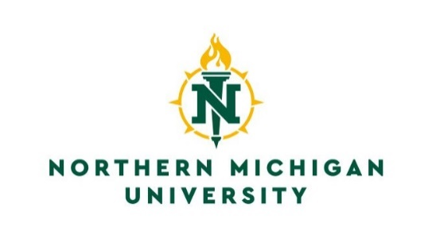

Registrar’s Office
C.B. Hedgcock, Room 2202
1401 Presque Isle Avenue
Marquette, Michigan 49855
(906) 227-2278
(906) 227-2231 Fax
Email: trnseval@nmu.edu

Advanced Placement Credit Form

I recommend and authorize that advanced placement credit be granted to:
________________________________________________ ________________________
Last First M.I. NMU IN

Course  I.D. No. |  | Course Title |  | Score if  Applicable |  | Semester  Hours

Credit is being granted as a result of:
Departmental Testing
Previous Training or Experience (attach documentation)
National Testing Programs (CEEB, CLEP, NLN, Other _________________)
Other (explain) ___________________________________________________________
________________________________________________________________________

_______________________ ____________________________________
Date Signature of Department Head

____________________________________
Department Name
Please return this form to the Office of the Registrar, C.B. Hedgcock, Room 2202.
Retain one copy for your records.

_______________________ ____________________________________
Date Registrar’s Office Approval

Regulations Governing Advanced Placement

- The applicant must be admitted and enrolled at NMU.
- Course prerequisites, if any, must be met before credit by examination will be considered for course equivalency and credit.
- Credit will not be awarded for any course below the level of a course for which the student already has credit or in which the student is currently enrolled unless approval in writing is obtained through the department head or appropriate departmental committee.
- “Special Topics” or “Directed Studies” courses are excluded from credit through advanced placement.
- Departments may exclude any departmental course credit by examination.
- Departments have a choice of: A) giving a comprehensive examination; B) requiring extensive documentation of previous life and/or educational experience; or requiring both A) and B).
- At the department’s discretion, CLEP and AP tests may be used.
- Once a student has enrolled at NMU, credit cannot be earned by examination through another institution unless approved in advance by NMU.

