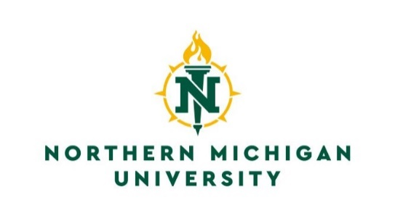

Registrar’s Office
C.B. Hedgcock, Room 2202
1401 Presque Isle Avenue
Marquette, Michigan 49855
Phone: (906) 227-2278
Fax: (906) 227-2231
Email: records@nmu.edu

Request for Verification of Enrollment

Name:_____________________________________ Date of Birth:________________________

NMU IN:_____________________________ Local Phone #:_____________________________

I authorize release of information requested in this letter to the Registrar’s Office

______________________________________________________________________________
Signature of Student Date

Semester(s):____________________________________________________________________

Specify Enrollment Status in Letter (part/full time): Yes_____ No_____

Pick up letter: Yes_____ No_____

Email letter: Yes_____ No_____

Fax letter: Yes_____ No______ Fax Number: ______________________________

Mail letter: Yes_____ No______

Mailing letter Address: ____________________________________________________________

____________________________________________________________

____________________________________________________________

Additional Information Needed in Letter:

______________________________________________________________________________

Note: This form is for current and recently enrolled students only. It is not to be used in place of a transcript. Processing takes 2-3 business days once received by the Registrar’s Office.

