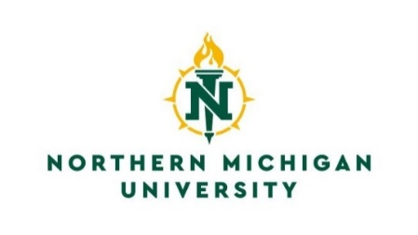
Registrar’s Office
C.B. Hedgcock, Room 2202
1401 Presque Isle Avenue
Marquette, Michigan 49855
(906) 227-2278
(906) 227-2231 Fax
Email: records@nmu.edu

Request to Prevent Disclosure of Directory Information

The items listed below are designated as directory information and may be released for any purpose at the discretion of Northern Michigan University.

Under the provisions of the Family Educational Rights and Privacy Act of 1974, as amended, you have the right to withhold the disclosure of directory information.

I _______________________________________________________, _________________________________,
PRINT OR TYPE FULL NAME NMU IN

request that the university prevent the disclosure of the information checked below:

☐ NAME & ALL DIRECTORY INFORMATION LISTED BELOW:
LOCAL ADDRESS AND TELEPHONE (including cell phone number).
PERMANENT ADDRESS AND TELEPHONE (including cell phone number).
ENROLLMENT STATUS (Enrollment status, major/minor, program level (e.g. vocational, undergraduate, etc.), class standing, date(s) of attendance, current term candidacy for degree or certification, degree(s) earned (including dates), honors and awards).
NMU EMAIL ADDRESS (NMU email address will continue to be used as the official means of communications at this university. Only the printing of it in the online directory will be restricted.)

Please consider very carefully the consequences of any decision by you to withhold any directory information. NMU staff will not be able to assist you over the phone nor will the university acknowledge your presence as a student to outside agencies or include you in university publications and press releases (e.g. Dean’s List). You will assume complete anonymity and you will have to conduct all university business in person with a photo ID or using self-serve technology from your My.NMU account.

NMU will honor your request to withhold directory information until you request that the restriction be removed but cannot assume responsibility to contact you for subsequent permission to release information.

At this time, I would like to request non-disclosure of all directory information listed above. I understand the implications of this request and that this request to prevent disclosure of the selected directory information remains in effect until I provide a signed Release of Directory Information form to NMU Registrar’s Office or Student Service Center.

SIGNATURE: _______________________________________________ DATE: ______________________

Please email this form from your NMU email address to records@nmu.edu. If emailing from another email address, a picture I.D. will need to be attached. If submitting this form in person, please bring a photo I.D.

For Office Use: ___ Confidentiality Flag Checked on Banner. Processor’s Initials: _____ Date:__________

